Queena Lin

CIS 310 Chapter 4 HW

**21. The local city youth league needs a database system to help track children who sign up to play soccer. Data needs to be kept on each team, the children who will play on each team, and their parents. Also, data needs to be kept on the coaches for each team.**

PART 1: This model describes conceptual view between the four entities PARENT, PLAYER, COACH and TEAM. The model demonstrated a M: N relationship. We can see that there is a strong relationship between PARENT and PLAYER and weak relationship between PLAYER and TEAM, TEAM and COACH. PARENT and PLAYER have a strong relationship because the two entity is connected by at least one PK(PARENT_ID) of the parent entity while the entities PLAYER, TEAM, and COACH does not contain at least one PK from the parent entity.

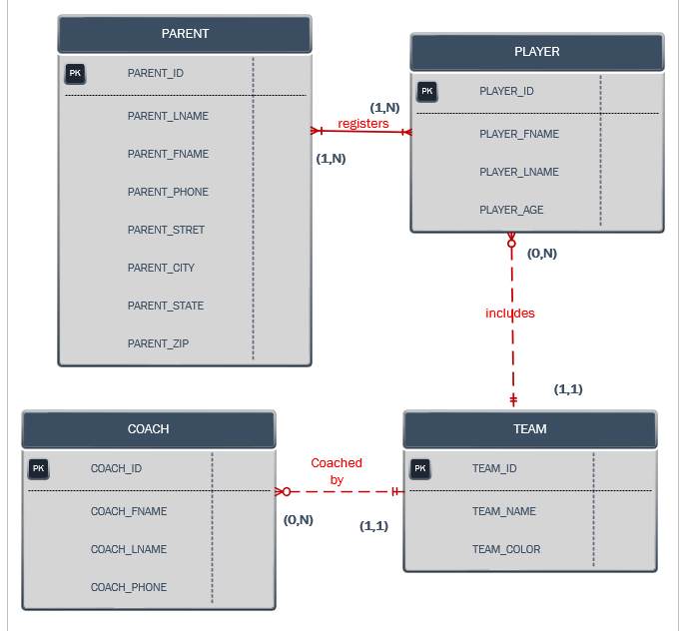

PART 2: M: N relationship needed to break up to 1:M by establishing foreign key and creating an entity name REGISTERS. PARENT and REGISTER have a strong relationship because you can see that the PK of PARENT is also the PK if REGISTERs (PARENT_ID). It is the same situation between REGISTERS and PLAYER which is related by PLAYER_ID. On the other hand, PLAYER, TEAM, and COACH consisted of a weak relationship because all their PK is different.

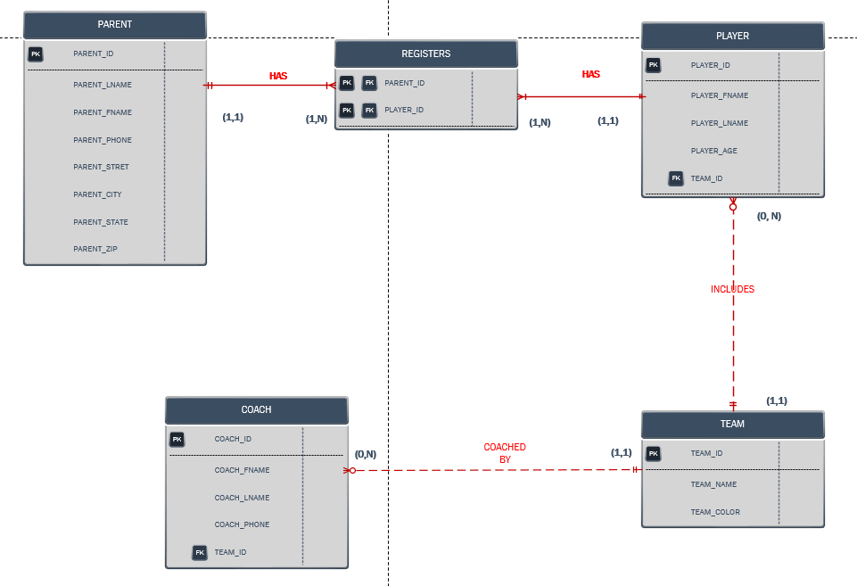

**Problem 1. Create an ERD for a medical clinic using the business rules depicted in problem 1, page 154.**

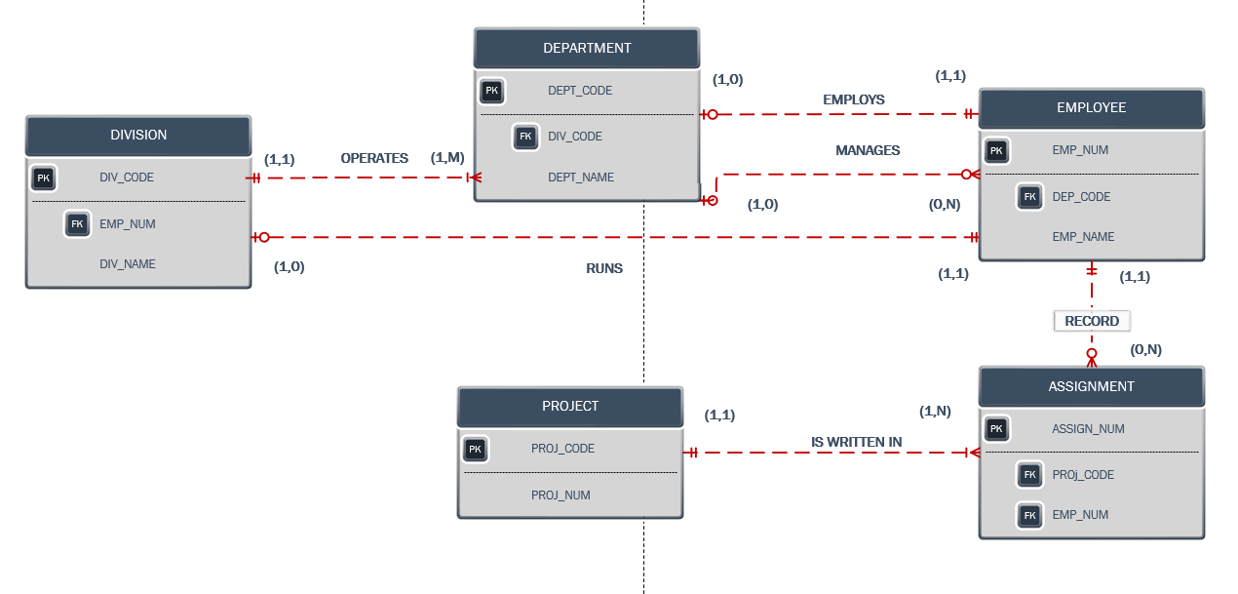

All the entity consisted of a weak relationship because all the entity does not have a PK which they inherited from their parent entity.